Development of new numerical models with use of optimization techniques
Mateusz Gawronski¹, Pawel Packo¹
¹AGH University of Science and Technology, Department of Robotics and Mechatronics, Krakow, Poland

Summary
Dynamic transient problems exhibit significant computational complexity from numerical point of view. This class of hyperbolic problems relates to the most general computational mechanics problem and its study can bring general conclusions and guidelines for numerical modelling of various mechanical systems. Choice of numerical techniques for elastic wave propagation is of great importance during simulation set up, due to their inherent deviations from exact solutions approaches. Not only the solution type tremendously affects the accuracy of the result but the choice of grid type and its parameters could result in discrepancies between the expected and computed responses.
In the presented work, analysis of numerical models based on their exact numerical spectral properties is presented. Specifically, numerical artefacts due to periodic nature of the model domain are discussed using Finite Difference and Finite Elements approaches. Subsequently, a new methodology for developing numerical models based on the optimisation strategy is proposed. The model development is set-up as an optimization problem minimising numerical errors present in the model. Hybrid optimisation techniques based on non-gradient Genetic Algorithms and gradient-based methods are employed to tune the model. Through the reference to direction-dependent spectral properties of the medium, model parameters are computed in order to compensate for discretisation effects, including the mesh-induced anisotropy in a given frequency/wavenumber range.
- Introduction
Accurate modelling and simulation of dynamic transient phenomena in elastic media has been of interest for the last few decades. One of the main reasons for this are wave propagation and interaction with structural features in linear and nonlinear media that can be used for measurement and diagnostic purposes. Numerical solutions are of practical interest for structural problems since analytical solutions typically do not exist. In those approximate solutions, errors due to the discretisation are present and project on the predicted responses. These may originate from spatial and time discretisation factors or from anisotropy of the grid or approximation (e.g. shape functions). Among the available methods, techniques that best compromise accuracy and computational burden or those best reproducing exact responses are selected.
In general, numerical methods employ some sort of parametrised algebraic equations, where the parameters are specific to a particular technique. However, the parameters differ when compared between modelling approaches (Leamy, 2014). Assuming that those parameters define properties of the model, the dynamic characteristics of the system (e.g. excitability and dispersion) can be tuned by modifying governing equations parameters.
This article proposes an optimisation-based approach for developing new numerical models by tuning their spectral properties. Consequently, spectral properties of the model (namely, dispersion characteristics) are adjusted to match analytical solution for infinite media. Through adopting hybrid optimisation procedure - consisting of two sequentially applied algorithms - dispersion characteristics for the model are optimised. The proposed approach leads to the best local solution for a given objective function.
The article is organized as follows. Section 2 gives a brief theoretical background on numerical dispersion estimation for infinite media and describes optimisation framework used for parameter tuning. Section 3 discusses results for a test case adopting the aforementioned optimisation method.
- Theoretical background
Spectral properties of wavefields
Spectral characteristics describe amplitude- and phase-frequency relations of waves propagating through the medium. It should be noted that those frequency-dependent properties differ between the analytical and numerical models (Packo, 2014) and the measure between those two inform about numerical errors introduced by space and time discretisations.
In the current work, only dispersion, i.e. phase-frequency, characteristics are employed in the optimisation. The dispersion curves of a numerical model are extracted from the algebraic iteration equations by adopting the procedure outlined in (Packo, 2014).

Optimization procedure
The proposed optimization procedure consists of three main parts: (1) the objective function, (2) the Genetic Algorithm (GA) (employed for global screening of the parameter space) and (3) a Gradient Method (GM) for local adaptation of the solution.
Proper construction of objective function, (1), is the most important step when designing an optimisation problem and determines the relevancy of the results. The objective function defines the direction in which the solution should converge in order to achieve best outcome. In the current work, the constraints are directly embedded into the goal function through the penalty functions. The general form of the goal function is of the form

$$ϑ= \frac{1}{f^{2}}\int_{f_{l}}^{f_{u}}{|V_{r}-V_{w}|df} +K$$

where the main part of equation is the difference between the reference V_{r} (analytical) and optimised V_{w} (numerical) dispersion characteristics. The integral is taken over the frequency domain of interest. Furthermore, the factor 1/f² is introduced in order to penalize errors at lower frequencies with the focus on obtaining best fit from the origin of the dispersion characteristic. Additional penalty factor K is introduced to embed other physical constraints into the system.
The optimisation strategy is based on two sequentially used algorithms - GA and GM. Their combination allows for global sweeping through the parameter domain and approaching a possible global minimum. After the initial GA-driven estimation is completed, GM-optimisation fine-tunes the solution to find the best fit.
- Results
Figure 1 presents results after optimisation using the hybrid GA and GM. The analytical solution (purple) is computed for an aluminium, i.e. Young modulus E = 69 GPa, Poisson’s ratio v = 0.33 and density ρ = 2700 kg/m³. The numerical model is assumed as a 2-D space discretised with a regular, square grid of elements with dimensions Δx = Δy = 0.5 mm.
Numerical model dispersion characteristics are evaluated at the edges of the Irreducible Brillouin Zone (Kijanka, 2016). As per construction of the goal function, the main focus was to achieve characteristics closest to the exact solution starting from the lowest frequencies. It can be seen that very good agreement was achieved. Due to low penalty factor for high frequencies (no particular focus on the fitness quality), middle area of the graph is not well matched with analytical solution. The overall quality of the optimised model can be studied through the cumulative error – i.e. a measure showing the total difference between the exact and numerical solutions up to the selected wavenumber. The cumulative error graph, Fig. 1, shows that the optimised result displays error level comparable to the FD-based LISA method. On the other hand, FEM cumulative error is substantially greater, showing numerical artefacts originating from mesh discretisation. It can be noted that the optimised model reduces the cumulative errors by approximately 30% when compared to the FEM and LISA models for the considered frequency range.

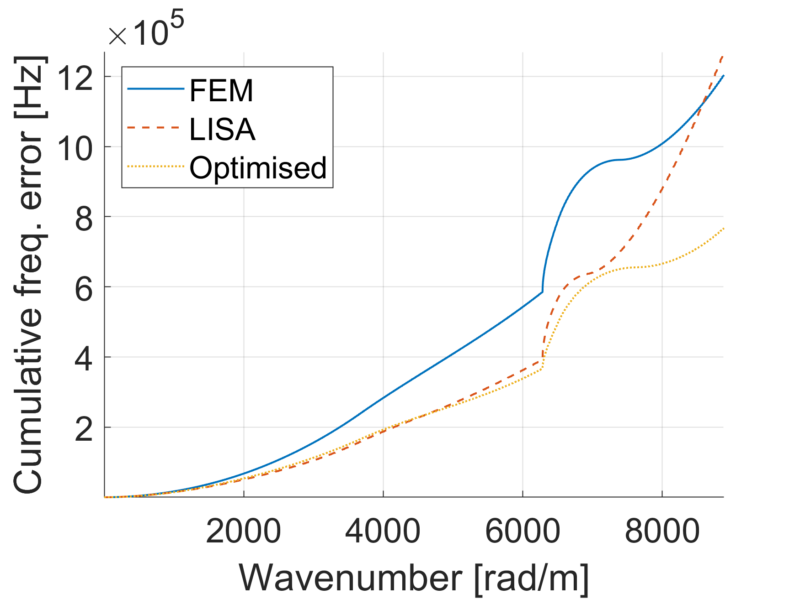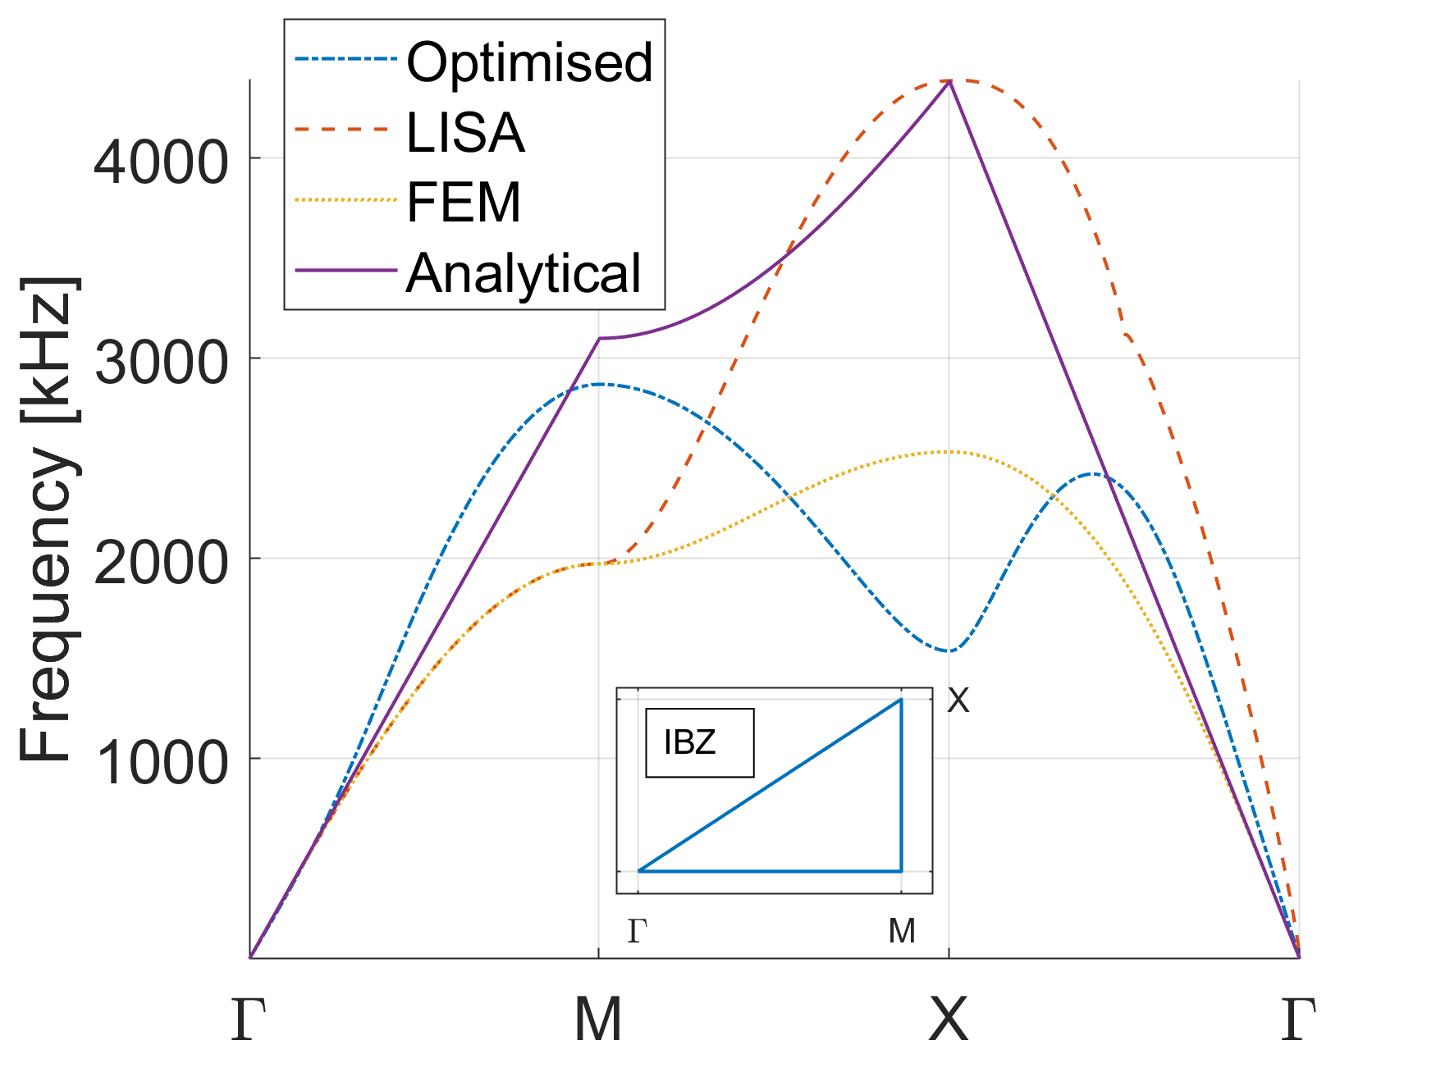
- Results for optimisation of model parameters and cumulative error comparison for LISA and FEM
Acknowledgments
The work presented in this paper was supported by the National Centre for Research and Development under the research LIDER programme (project No. LIDER/317/L-6/14/NCBR/2015). Research was supported in part by PLGrid Infrastructure
References
Michael J. Leamy, Thibaut B. Autrusson, Wieslaw J. Staszewski, Tadeusz Uhl, Pawel Packo (2014), ‘Local computational strategies for predicting wave propagation in nonlinear media’, Proc. SPIE, vol. 9064, ISBN: 9780819499905
Pawel Packo, Tadeusz Uhl, Wieslaw J. Staszewski (2014), ‘Generalized semi-analytical finite difference method for dispersion curves calculation and numerical dispersion analysis for Lamb waves’, The Journal of Acoustical Society of America, 136(3), 993-1002
Piotr Kijanka, Wieslaw J. Staszewski, Pawel Packo (2016), ‘Simulation of guided wave propagation near numerical Brillouin Zones’, proc. SPIE, vol. 9805, 2016

